HL7 Transport

HL7 stands for Health Level Seven, and the framework defines how messages are packaged and transported in clinical systems. HL7, meaning in healthcare, an HL7 message is a group of octets transmitted as a unit from a source to a destination. The message type determines the purpose of the note, the content, and the kind of content.

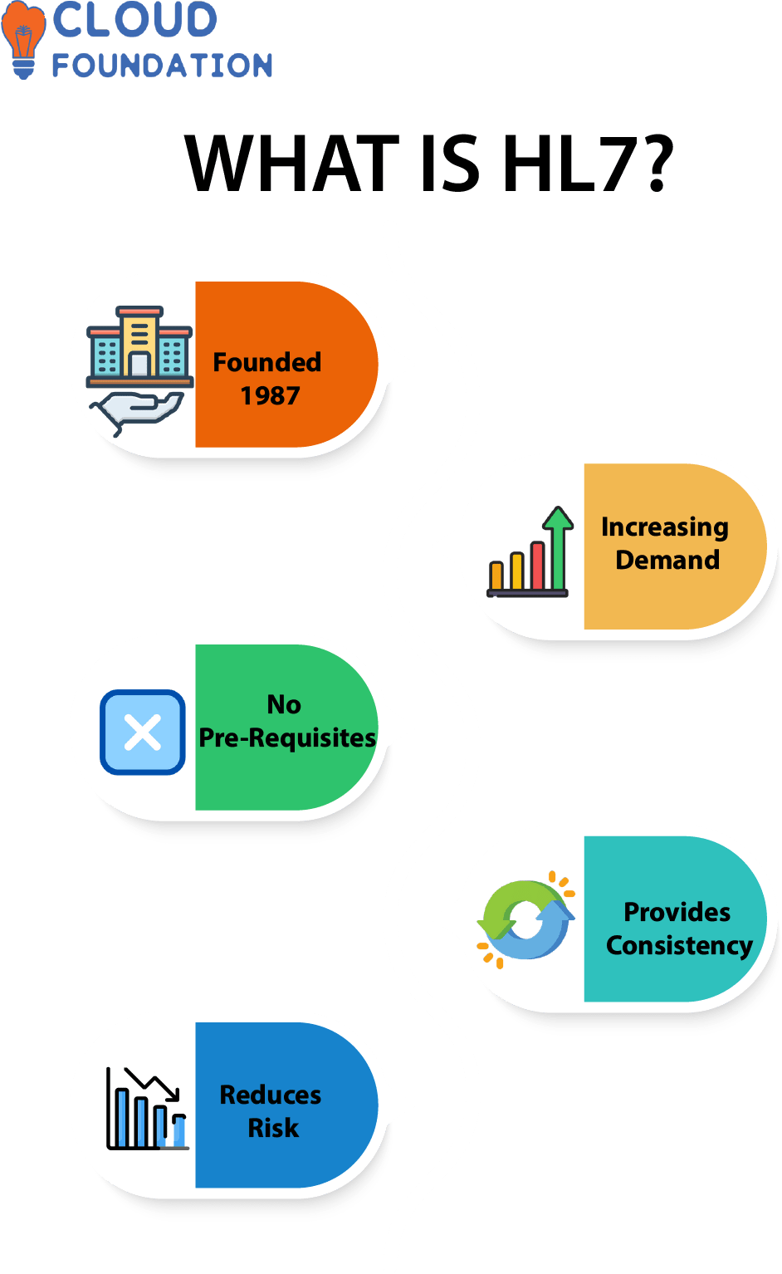

**What is HL7 Data?**

It also provides a **language for communication** between disparate medical software. Health Level Seven International initially developed this framework. This non-profit organization creates standards and guidelines for healthcare systems.

**What does HL7 do and what is HL7 used for?**

**HL7 is a machine-to-machine protocol** that helps healthcare organizations exchange information.

It focuses on the communication needs of patients, medical professionals, and administrative staff.

Also has proven itself over the years, and it’s commonly accepted in the healthcare industry. It’s a standard framework that provides a structure for messaging in the healthcare industry.

**Why use HL7?**

To define a common language that can be used to exchange data between disparate systems.

The HL7 standards allow for the interoperability of healthcare information systems and data exchange between healthcare providers.

They also provide a framework for implementing interfaces between various healthcare applications.

They offer national and international support as a non-profit organization that develops and **maintains clinical and administrative health data standards**.

1. Click on file select integration project.

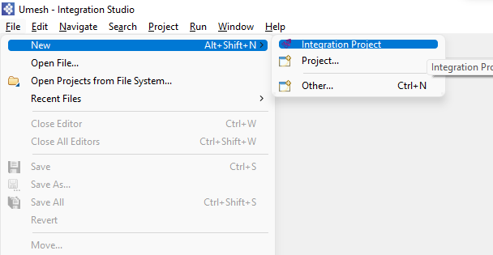

1. Select ESB config and Composite Exporter and enter name of project and click on finish.

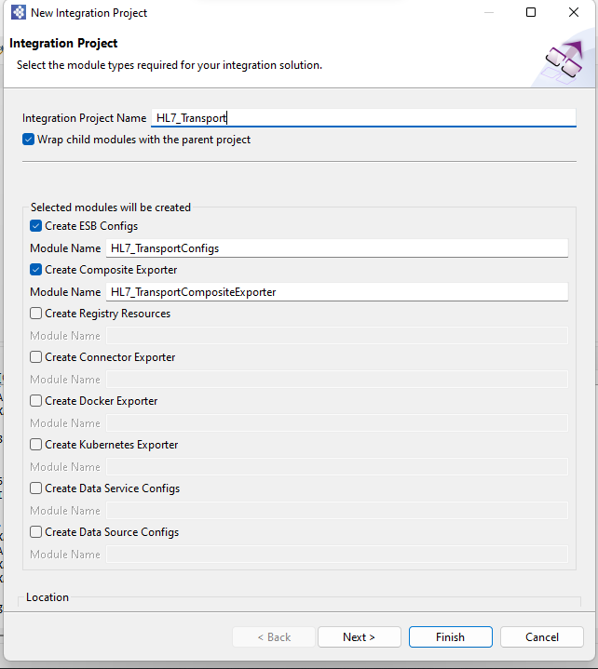

1. Click on Sequence artifact in ESB Config and click new, select Sequence

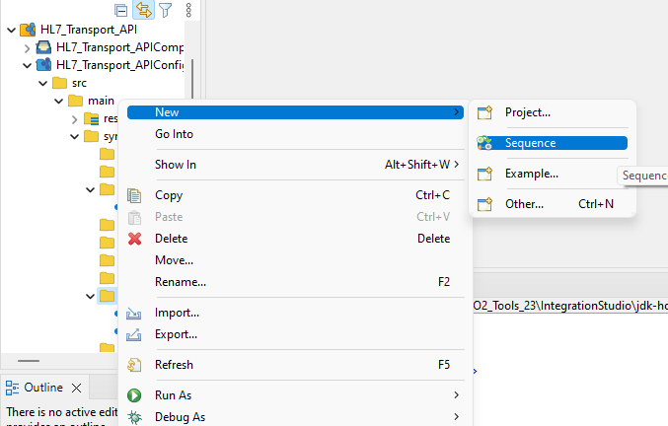

1. Select Create new sequence artifact and click on next

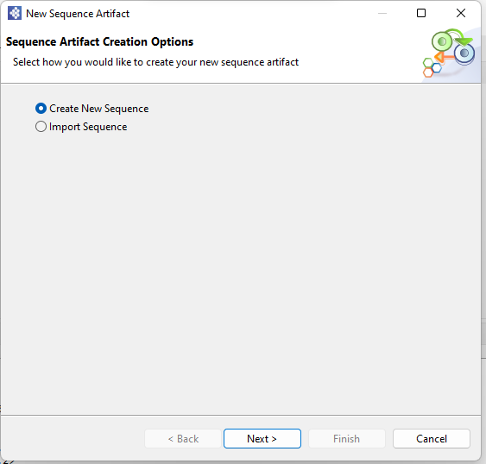

1. Enter Name of sequence and click on next.

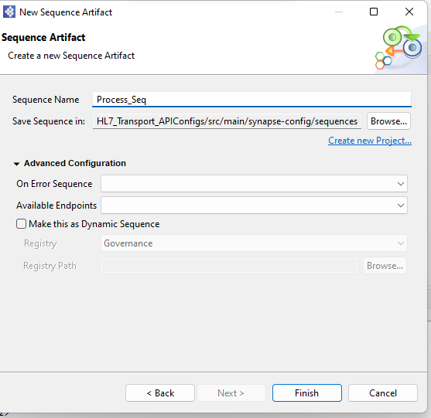

1. From the **Mediator** palette, click and drag a **log and drop** Mediator to the In sequence

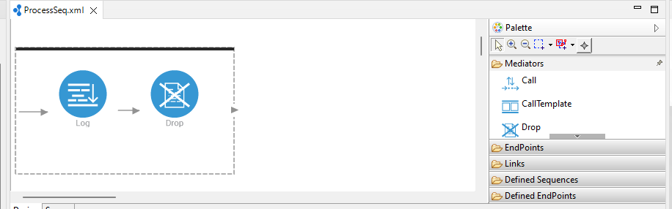

1. In log mediator property tab select log level full

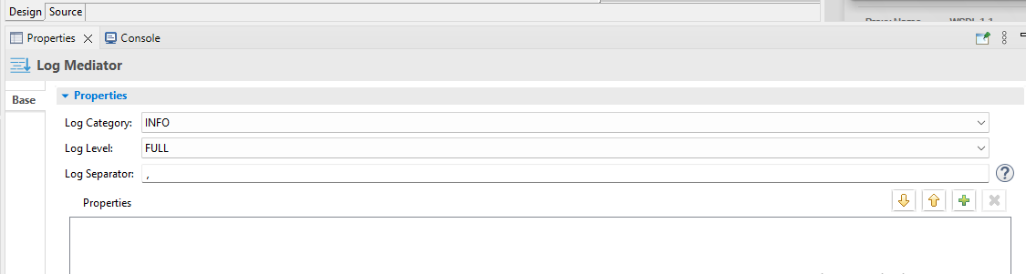

1. Create on more sequence enter name and click on next

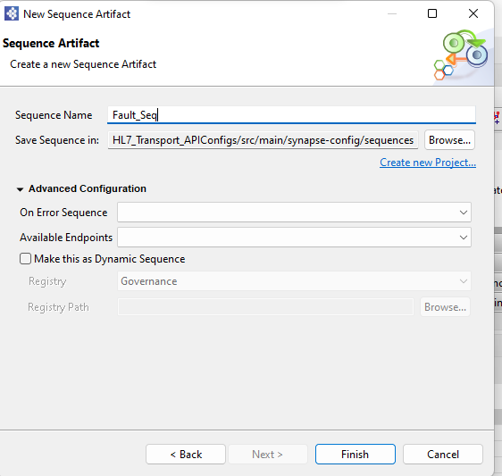

1. From the **Mediator** palette, click and drag a **log and drop** Mediator to the In sequence



1. In log mediator property tab select log level custom and add error handling properties

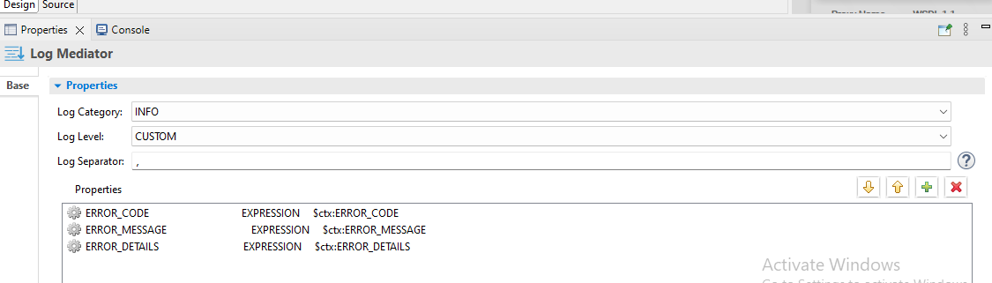

1. Click on Inbound Endpoint artifact in ESB Config and click new, select Inbound Endpoint

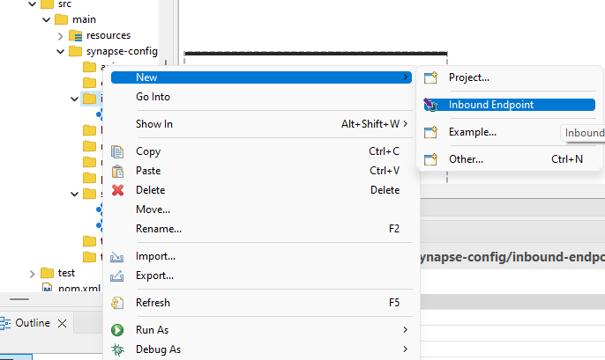

1. Select Create new Inbound Endpoint artifact and click on next

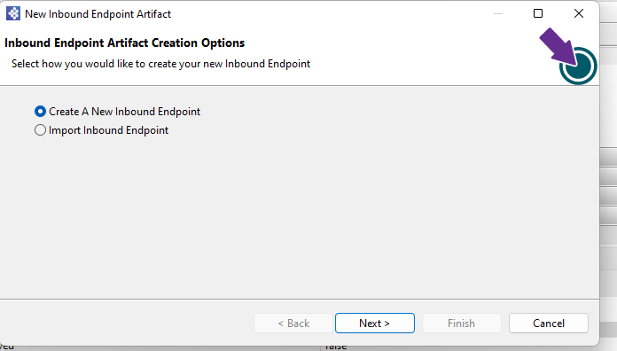

1. Enter name, Select type and select process sequence and error sequence and next.

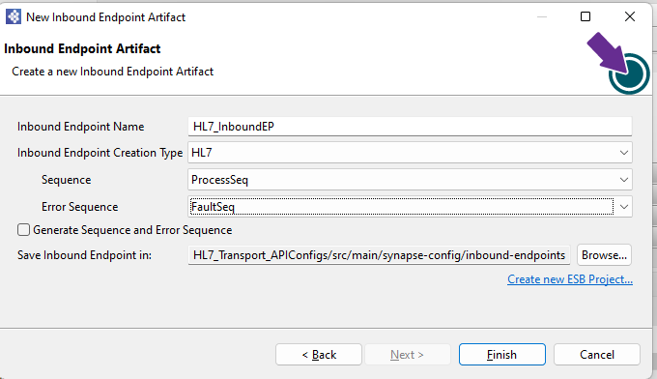

1. Add following properties hl7 port

<?xml version=*"1.0"* encoding=*"UTF-8"*?>

<inboundEndpoint name=*"HL7_InbondEndpoint"* onError=*"FaultSeq"* protocol=*"hl7"* sequence=*"ProcessSeq"* suspend=*"false"* xmlns=*"http://ws.apache.org/ns/synapse"*>

<parameters>

<parameter name=*"inbound.hl7.Port"*>20000</parameter>

<parameter name=*"inbound.hl7.AutoAck"*>true</parameter>

<parameter name=*"inbound.hl7.TimeOut"*>10000</parameter>

<parameter name=*"inbound.hl7.CharSet"*>UTF-8</parameter>

<parameter name=*"inbound.hl7.ValidateMessage"*>false</parameter>

<parameter name=*"inbound.hl7.BuildInvalidMessages"*>true</parameter>

<parameter name=*"inbound.hl7.PassThroughInvalidMessages"*>true</parameter>

</parameters>

</inboundEndpoint>

1. Right Click on the Composite Exporter and select Export project artifact and Run

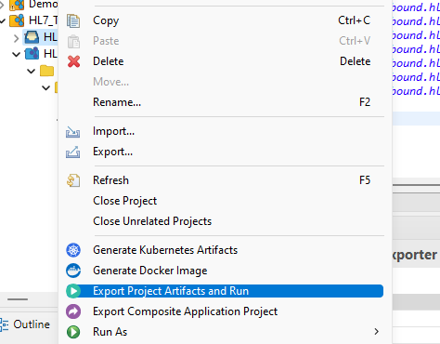

1. Download  **HAPI HL7 Test Panel and open and create click create new connection**

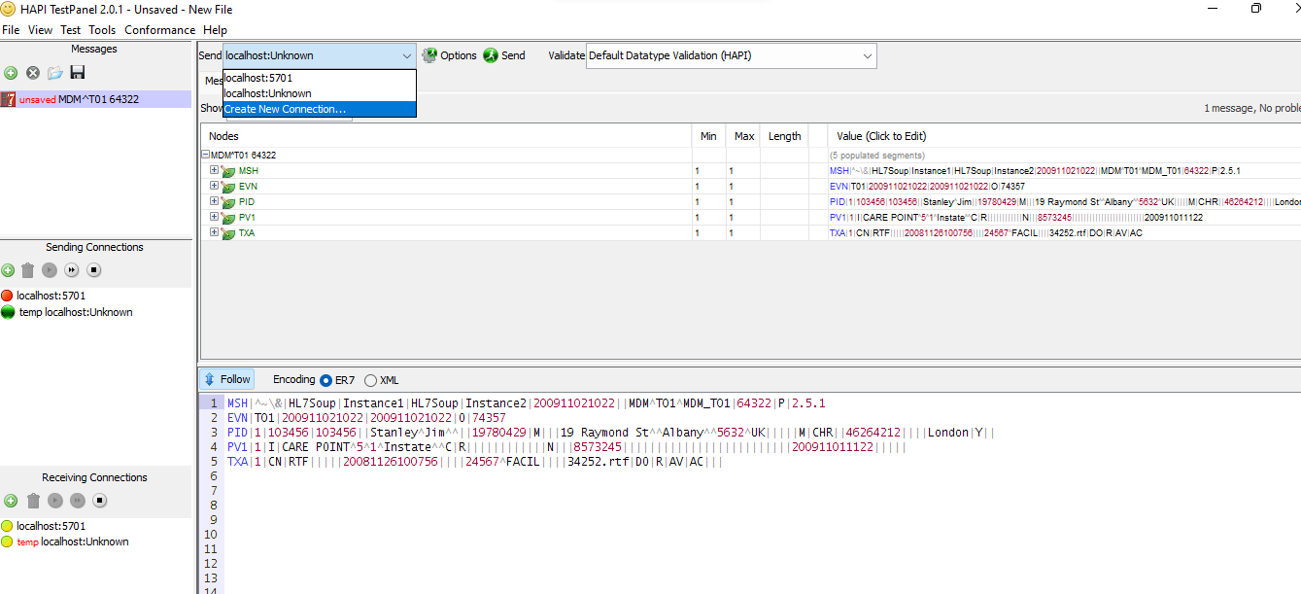

1. **Enter port which mention in inbound Endpoint and click on ok**

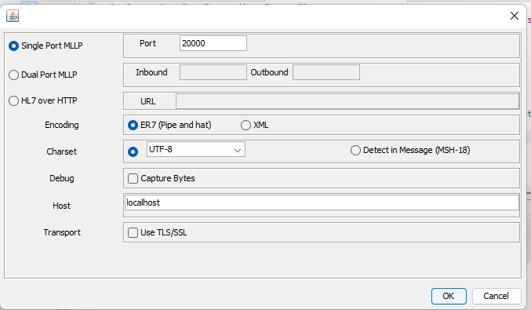

1. **Enter HL7 message and click on send**

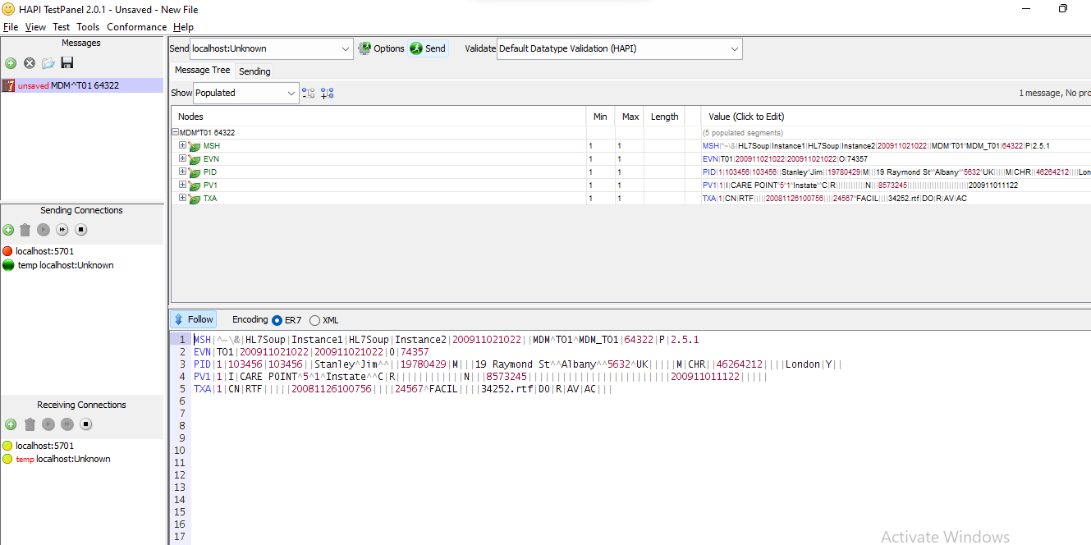

1. **Check in result in console**

